Instructions and template for extended abstracts

Martin Ziegler1*, David Jaeggi1 and Christophe Nussbaum1

1 Federal Office of Topography, Mont Terri Underground Rock Laboratory, St-Ursanne, Switzerland

2 Please indicate further author affiliations with consecutive numbering

* martin.ziegler@swisstopo.ch

# Deadline

The extended abstract submission deadline is August 31st, 2025. Extended abstracts will be peer-reviewed by a scientific committee and potential revisions shall be made by October 31st, 2025.

# Language

Abstracts should be submitted in British English or American English.

# Extended abstract size and naming convention

Your abstract should not exceed 4 pages in the format shown here including optional figures, captions and references. Please make sure that the file names are in the form: surname_name (e.g., Albert Einstein: einstein_albert.docx, einstein_albert.pdf). Please leave the abstract number empty.

# Title and authors

For the title, please capitalize the first word only and list authors by order of contribution to the extended abstract with "Full_first_name_author1 Surname_author1", Full_first_name_author2 Surname_author2", etc…. For each author, please indicate the institution and provide the e-mail address of the main author. Please underline the presenting author.

# Pre-defined text styles and further instructions

## Pre-defined text styles

Please use the predefined styles (Table 1).

Table 1. Predefined styles

|  |  |
| --- | --- |
| **Text element** | **Pre-defined Style** |
| Abstract title | use «Title» |
| Addresses of authors | use «Address» |
| Authors | use «Authors» |
| Body text | use «Body text» |
| Bullet lists | use «Bullets» |
| Figure and table captions | use «Figure caption» and «Table caption» |
| Reference list | use «Reference list» |
| Section headers | use «Section header» and «Sub-header» |
| Table text | use «Table text» |

## Further instructions

Use Arial 11, 1.15 spacing, italics and scientific notations according to standard international rules. Margins are given by this template. The abstract file should be submitted in .docx format. In addition, we request the submission of a .pdf file to enable us to check for correct reproduction of special characters. Use automatic hyphenation.

# Figures, photographs and tables

We recommend to submit drawings and photographs in pixel form (e.g. .tif, highest quality .jpg). Please make sure that you scale your illustration to printing size (maximum 24 cm x 17 cm). Please check that your figures and included text are readable at this size (avoid text smaller than 8pts). We recommend a resolution of 600 dpi for pictures and graphics. Mention the name of the photographer or the source in the caption. Please put captions directly below figures and photographs (see below) and above tables. Please include all texts and annotations in the figures themselves. DO NOT add texts or annotations over the figures in your text editor. For tables stick to the illustrated format.

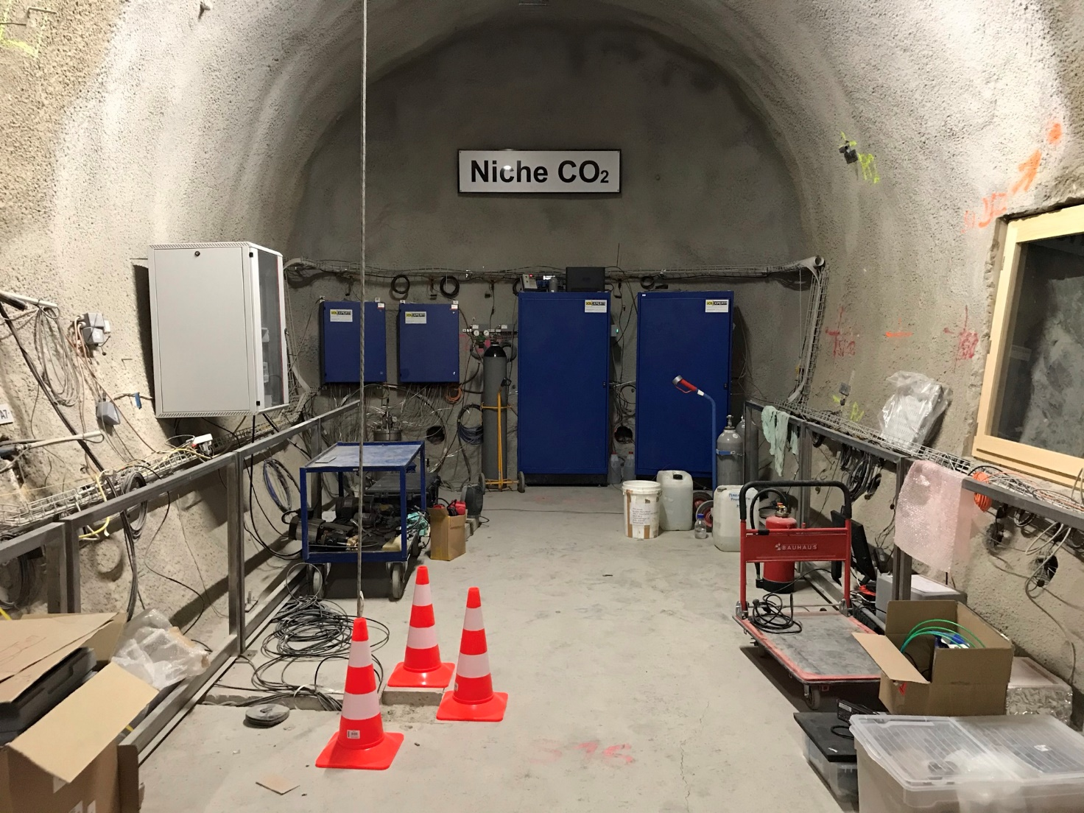

Figure 1. Photograph of the Niche CO2 inside the Mont Terri URL (photograph by R. Nicol).

# References

Please put references at the end of the extended abstract text. References should be cited in the text as follows:

* Author & Author (1989) *instead of* Author and Author (1989)
* (Author 1989a, b; Author & Author 1987) *instead* *of* (Author, 1989a,b; Author & Author, 1987)
* (Author et al. 1989) *instead of* (Author, Author & Author 1989)
* *Use the following style:* (Author, in press); (Author, in prep.); (Author, unpubl.); (Author, pers. comm.)

# Reference list

Ajayi, T, Gomes, JS, Bera, A. 2019. A review of CO2 storage in geological formations emphasizing modeling, monitoring and capacity estimation approaches. Pet. Sci. 16, 1028–1063. https://doi.org/10.1007/s12182-019-0340-8

Iglauer, S, Al-Yaseri, AZ, Rezaee, R, Lebedev, M. 2015. CO2 wettability of caprocks: implications for structural storage capacity and containment security. Geophys. Res. Lett., 42 (21), 9279–9284. https://doi.org/10.1002/2015GL065787

Matter, JM, Stute, M, Snæbjörnsdottir, SÓ, Oelkers, EH, Gislason, SR, Aradottir, ES, et al. 2016. Rapid carbon mineralization for permanent disposal of anthropogenic carbon dioxide emissions. Science 352 (6291), 1312–1314. https://doi.org/10.1126/science.aad8132

Niemi, A, Bensabat, J, Bear, J (eds.). 2017. Geological storage of CO2 in deep saline formations. Springer, Dordrecht. 554 pp.

Ziegler, M, Nicol, R, Jaeggi, D, Windisch, J, Nussbaum, C. 2024. 1st Caprock Integrity & Gas Storage Symposium. Extended abstracts. St-Ursanne, January 24–25, Switzerland, 174 pp. https://doi.org/10.60695/swisstopo-25012024